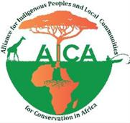

ALLIANCE FOR INDIGENOUS PEOPLE’S AND LOCAL COMMUNITIES FOR CONSERVATION IN AFRICA
(AICA)

TERMS OF REFERENCE: CONSULTANCY
Capacity Strengthening of Government Officials and IPLC Leaders on Human Rights-Based Conservation and Development of Multilingual Training Toolkits

With Support from

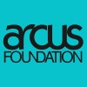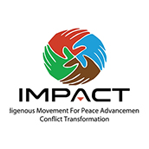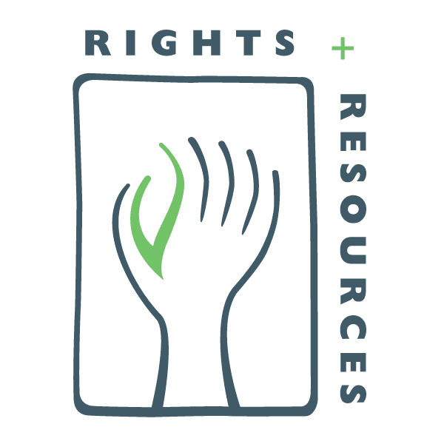

In partnership with;
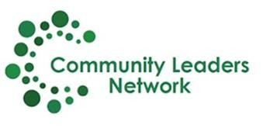
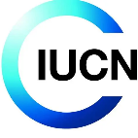

1. Introduction and Background
The Alliance for Indigenous Peoples and Local Communities for Conservation in Africa (AICA) is a Pan-African platform established to unify and amplify the voices of Indigenous Peoples and Local Communities (IPLCs) across Africa. AICA advances IPLC rights, promotes inclusive conservation, and strengthens representation in policy and decision-making processes related to land, territories, and natural resources.
AICA’s work is grounded in rights-based approaches to conservation, recognizing IPLCs as rights holders, knowledge holders, and key actors in governance systems. Through its strategic priorities, AICA seeks to influence policy, strengthen community leadership, and promote equitable and inclusive conservation models across the continent.
Despite increasing global commitments to human rights-based conservation, significant gaps remain in awareness, capacity, and practical application of these principles among both government institutions and IPLC leadership. Strengthening these capacities is essential to ensuring that conservation approaches respect human rights, promote equity, and support sustainable livelihoods.

2. About the Project
Under the Arcus Foundation Grant, AICA is implementing a regional initiative aimed at strengthening inclusive conservation and advancing rights-based approaches in Great Ape range countries in Central and West Africa.
This consultancy contributes to building the capacity of:
- Government officials
- Indigenous Peoples and Local Communities (IPLC) leaders
to understand and apply UNEP human rights principles and norms in conservation.
The assignment will also support the development of practical, user-friendly training toolkits in French and Swahili, and strengthen the ability of IPLCs to effectively engage with government institutions and conservation agencies.

3. Purpose and Objectives
Purpose
To design and implement a comprehensive capacity strengthening program that enhances understanding and application of human rights-based approaches to conservation, while empowering IPLCs to effectively participate in governance and decision-making processes.

Specific Objectives
- Strengthen knowledge of UNEP human rights principles and norms among government officials and IPLC leaders
- Enhance IPLC capacity to engage in policy dialogue, advocacy, and conservation governance processes
- Promote inclusive and constructive dialogue between IPLCs, government institutions, and conservation actors
- Develop high-quality, contextually relevant training toolkits in French and Swahili
- Support the integration of human rights-based approaches into conservation planning and implementation

4. Scope of Work
The consultant will undertake the following tasks:

4.1 Inception and Planning
- Review relevant project documents and background materials
- Engage AICA Secretariat to refine scope, expectations, and target countries
- Develop and submit an Inception Report outlining:
  - Detailed methodology
  - Workplan and timelines
  - Stakeholder mapping
  - Training approach
  - Risk assessment and mitigation measures

4.2 Training Curriculum Development
- Develop a structured training curriculum aligned with:
  - UNEP human rights principles and norms in conservation
  - Rights-based approaches to conservation
  - IPLC governance, participation, and advocacy
- Ensure inclusion of:
  - Case studies from African contexts
  - Practical tools and exercises
  - Interactive and participatory learning methods

4.3 Development of Training Toolkits
- Develop comprehensive training toolkits including:
  - Facilitator guides
  - Participant manuals
  - Visual and learning materials
- Translate and adapt materials into:
  - French
  - Swahili
- Ensure materials are:
  - Culturally appropriate
  - Accessible to IPLCs
  - Suitable for replication and long-term use

4.4 Training Delivery
- Facilitate training workshops in selected Great Ape range countries
- Apply participatory and inclusive methodologies
- Ensure representation of:
  - IPLC leaders (including women, youth, marginalized groups)
  - Government officials
  - Conservation stakeholders

4.5 Facilitation of Dialogue and Engagement
- Facilitate dialogue platforms between IPLCs and government institutions
- Strengthen IPLC capacity to:
  - Engage in negotiations
  - Participate in policy processes
  - Advocate for rights-based conservation

4.6 Documentation and Reporting
- Document training processes, participation, and outcomes
- Capture lessons learned, challenges, and best practices
- Provide recommendations for scaling and sustainability

5. Methodology
The consultant will adopt a participatory, inclusive, and rights-based approach, including:
- Co-design of training content with IPLC representatives
- Application of adult learning and experiential techniques
- Use of context-specific and case-based learning approaches
- Integration of Indigenous and Traditional Knowledge (ITK) perspectives
The methodology will be detailed in the Inception Report.

6. Deliverables
The consultant will be expected to deliver:
- Inception Report (methodology, workplan, training approach)
- Training curriculum and materials
- Training toolkits in French and Swahili
- Training workshops delivered (number to be agreed with AICA)
- Documentation of training sessions and participation
- Final capacity strengthening report including:
  - Outcomes and achievements
  - Lessons learned
  - Recommendations
All deliverables should be submitted in clear, professional English, with translated materials as required.

7. Payment Schedule
- Inception Report: 30%
- Training delivery and draft outputs: 30%
- Final deliverables: 40%

8. Qualifications
- Advanced degree in human rights, conservation, social development, or related field
- Minimum of 7 years of relevant experience
- Proven experience in training design and facilitation
- Demonstrated experience working with IPLCs and community-based approaches
- Strong understanding of human rights-based approaches to conservation
- Fluency in English and working knowledge of French and/or Swahili required

9. Selection Criteria

Criterion | Weight
Relevant experience and expertise | 30%
Quality of technical proposal | 30%
Training methodology and approach | 25%
Financial proposal | 15%

10. Duration
The assignment will be implemented over a period of 3–4 months within the Arcus Foundation project implementation timeline, with an estimated level of effort of approximately 40 working days.
The consultancy will be delivered in phases, including inception, curriculum development, toolkit production, training delivery, and reporting, and will be aligned with the scheduling of program activities and stakeholder availability across selected Great Ape range countries.

11. Intellectual Property
All data, materials, and outputs produced under this consultancy shall remain the property of AICA. The consultant shall not disclose or use such materials for any purpose outside this assignment without prior written consent.

12. Application Process
Interested candidates should submit separate technical and financial proposals.
- The technical proposal should include:
  - Understanding of the assignment
  - Proposed methodology and training approach
  - Workplan
  - Relevant experience and qualifications
  - At least three traceable references
- The financial proposal should clearly indicate total cost, including all applicable taxes and expenses.
Applications should be submitted either:
- Physically in sealed envelopes to:
7 Rossini Street, Pelican Square, Block B, Windhoek West
OR
- Electronically via email with subject lines:
  - “Technical Proposal – Training and Capacity Strengthening Consultancy”
  - “Financial Proposal – Training and Capacity Strengthening Consultancy”
Sent to:
secretariat@aica-africa.org
Copy info@communityln.org
Deadline: XXXXXXXX 2026 at 17:00 CAT

